Swiggy Sales Analysis
Business Problem:
Food delivery networks need insights into how time, geography, and customer preferences affect order demand and revenue. This project analyses real-time Swiggy transaction data to identify purchasing patterns that help optimize promotional planning, manpower allocation, and overall business profitability.
Dataset Description:
Data Source:
Real-time Swiggy Transactions Dataset Rows: ~197,000 order records Columns: 10 original + 4 engineered features
Key Variables:
- State & City
- Order Date
- Restaurant Name & Location
- Category
- Dish Name
- Price
- Rating
- Rating Count
Additional features added:
- Food Type (Veg / Non-Veg)
- Day
- Quarter
- Week

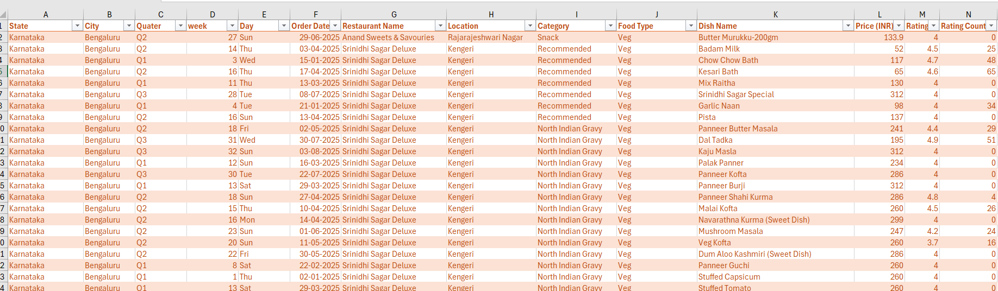

Data Collection:
The Swiggy transactional dataset was sourced from a publicly available real-time data extract, containing approximately 197,000 order records spanning January to August 2025. The raw dataset was downloaded and imported directly into Excel for processing.
To enrich the dataset for deeper analysis, several features were engineered from the existing columns. A Food Type classifier was built using keyword-based text analysis on dish names to categorize each order as either Veg or Non-Veg. Additionally, time intelligence columns — Day, Week, and Quarter — were derived from the Order Date field to enable granular trend analysis across different time dimensions.
Data Cleaning:
Cleaning & Preparation Steps:
- Verified no missing or blank values across key columns
- Converted raw data range into a dynamic Excel Table format
- Corrected auto-formatted Week column from Date type to Number
- Extracted Day name and Quarter from the Order Date column
- Standardized all numerical fields to consistent formatting
Feature Engineering:
- Food Type
- Day
- Quarter
- Week
Food Type = IF + OR formula scanning Dish Name for keywords:
- Non-Veg (chicken, mutton, egg, fish, prawns, etc.)
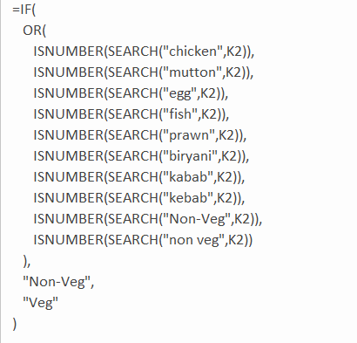
- Veg (no non-veg keywords found)

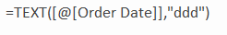
Day = TEXT(Order Date, "ddd") → returns 3-letter day initial (Sun, Mon, Tue, etc.)

Quarter = INT((MONTH(Order Date) + 2) / 3) concatenated with "Q" → returns Q1, Q2, Q3

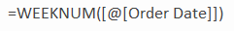
Week = WEEKNUM(Order Date) → returns numerical week of the year

Key Findings & Business Insights:
Key Insights:
- Order demand peaks on weekends (Sat & Sun); lowest on Mon & Tue
- January records the highest sales (₹6.8M+); February is the weakest month
- Vegetarian orders dominate with 64% of total sales share
- Bangalore is the top revenue city, followed by Lucknow, Hyderabad, Mumbai, and New Delhi
- Karnataka, Uttar Pradesh, and Maharashtra lead in state-level sales
- States lacking metro hubs (J&K, Nagaland, Assam) record the lowest sales
- Quarterly performance shows a flat trend with no significant growth across Q1–Q3
Pre-Visualization Steps:
- Built Pivot Tables to aggregate Total Sales, Average Rating, and Total Orders
- Calculated Average Order Value (AOV) manually outside pivot tables
- Extracted KPI values into standalone cells using GETPIVOTDATA for dashboard linking
- Applied custom number formatting (K/M suffixes, ₹ symbol, decimal precision)
- Extracted State and Sales data separately to enable Excel Map Chart compatibility

Visualization:
Tools:
- Microsoft Excel (Primary — Pivot Charts, Map Charts, Dashboard UI)
Example Visuals:
- Monthly Sales Trend (Line Chart)
- Sales by Food Type — Veg vs Non-Veg (Donut Chart)
- Daily Sales Trend (Bar Chart)
- Quarterly Performance Summary (Data Grid)
- Total Sales by State (Map Chart)
- Top 5 Cities by Sales (Horizontal Bar Chart)
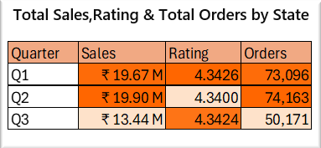
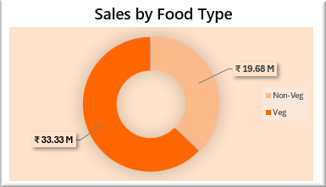
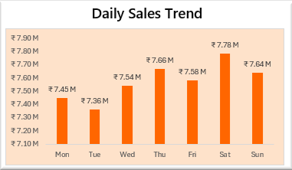
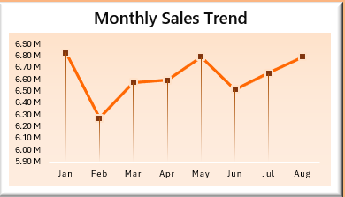
- Weekly Sales Trend (Bar Chart)
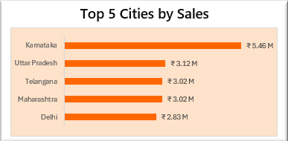
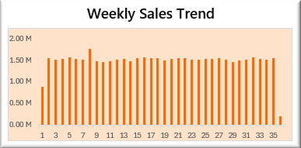

Dashboard:
An interactive and dynamic Excel dashboard was created to allow business owners and stakeholders to explore Swiggy's real-time food delivery data across India.
Key dashboard sections:
- High-Level KPIs (Total Sales, AOV, Ratings, Total Orders)
- Monthly, Weekly & Daily Sales Trends
- Geographical Sales by State & Top 5 Cities
- Veg vs Non-Veg Food Preference Analysis
- Quarterly Performance Summary
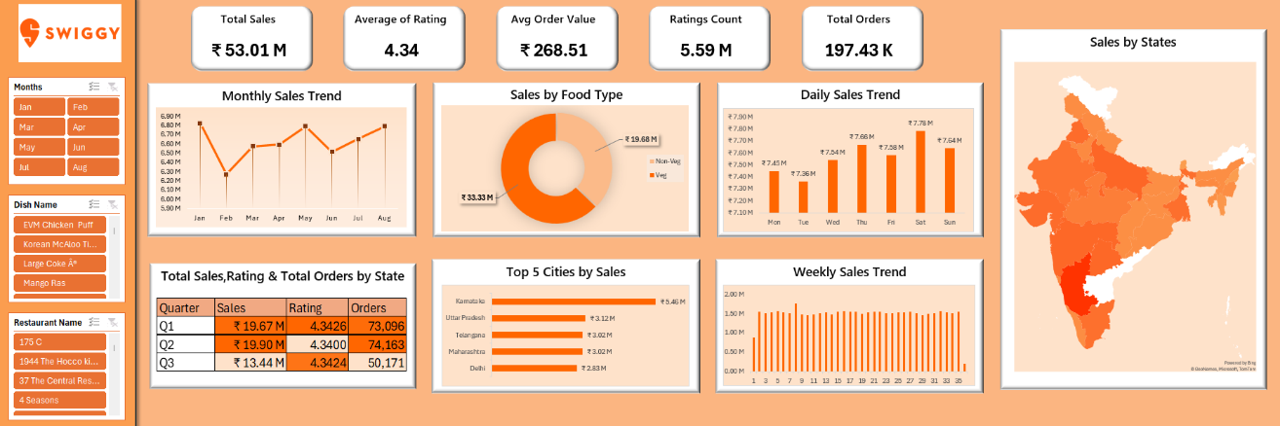
- Interactive Slicers & Sheet Navigation Buttons
Key Insights:
- Weekends (Sat & Sun) generate the highest order volumes; Mondays are the slowest
- January is the highest-revenue month at ₹6.8M+; February records the lowest
- Vegetarian orders account for 64% of total sales share
- Bangalore is the top-performing city, followed by Lucknow, Hyderabad, and Mumbai
- States without metro hubs (J&K, Nagaland, Assam) record the lowest sales
- Quarterly performance remains flat with no significant growth across Q1–Q3
- Overall: 197K+ orders, ₹53M total sales, ₹268 AOV, 4.34 average rating
Business Recommendations:
- Increase delivery manpower during weekends and peak months (January, May, August)
- Run targeted discounts on Mondays, Tuesdays, and slow months (February, June)
- Prioritize operational expansion in metro cities and IT hubs (Bangalore, Lucknow, Hyderabad)
- Introduce aggressive growth strategies to break the flat quarterly sales trend
- Heavily promote vegetarian options to capitalize on the 64% majority food preference

Tools Used:
Primary Tool:

- Microsoft Excel
Excel Features Used:
- Pivot Tables & Pivot Charts
- IF, OR, TEXT, INT, MONTH, WEEKNUM functions
- GETPIVOTDATA for dynamic KPI extraction
- Custom Number Formatting (₹, K, M suffixes)
- Shapes, Text Boxes & Linked Pictures for dashboard UI
- Slicers for interactive filtering
- Map Charts for geographical visualization

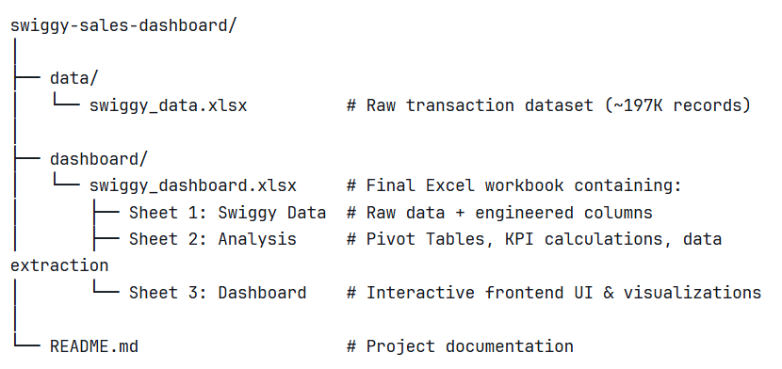
Project Structure:
Limitations:
- Map Charts cannot be generated directly from Pivot Tables; data must be extracted to standalone cells first
- Geographical map rendering requires an active internet connection
- Dashboard KPIs cannot be linked directly to Pivot Table cells; values must be referenced externally
- Excel performance degrades significantly when handling ~197K rows with multiple Pivot Tables and linked visuals
- Dataset is limited to January–August 2025, restricting full-year trend analysis
- Analysis is restricted to available columns; customer demographics and delivery time data are not captured
Future Improvements:
- Migrate dashboard to Power BI, Tableau, or Python for more robust and scalable analysis
- Implement advanced DAX functions and measures in Power BI for deeper calculations
- Introduce aggressive growth strategies to break the stagnant quarterly sales flat line
- Push targeted discounts and offers during low-performing periods (February, Mondays, Tuesdays)
- Incorporate additional data points such as delivery time, customer demographics, and return order rates for richer insights

